Data Analysis Bike sales Project Report

Project Overview
This project analyzes data from the provided dataset to uncover patterns, trends, and actionable insights.

Files Included
- Excel file (Dashboard )
- Word file (Report)
- Excel file( Raw Data)
- Screen shot

Tools Used
- Microsoft Excel,
- Pivot Tables,
- Charts, Data Cleaning Techniques

Problem Statement
The dataset provides demographic, socioeconomic, and behavioural information about individuals, including variables such as age, gender, marital status, income, education, occupation, commute distance, and region. It also records whether or not a bike was purchased. While the data is rich in detail, it does not directly explain the factors influencing bike purchase decisions.
The challenge is to analyse this dataset to uncover patterns in consumer behaviour, identify key demographic and socioeconomic drivers of bike purchases, and explore how lifestyle factors (such as commute distance, income, and education) interact with purchasing decisions. This analysis can help businesses in the cycling industry design targeted marketing strategies, optimize product offerings, and improve customer segmentation.

Research Questions
1. Demographic Factors
- How do age groups (Adult, Middle Age, Old) influence the likelihood of purchasing a bike?
- Are there significant differences in bike purchases between male and female customers?
- Does marital status (single vs. married) affect bike purchase decisions?
2. Socioeconomic Influences
- How does income level correlate with bike ownership or purchase?
- What role does education level (High School, Bachelors, Graduate Degree, etc.) play in bike purchase behaviour?
- Do certain occupations show higher tendencies to purchase bikes compared to others?
3. Lifestyle & Behavioural Factors
- How does commute distance (0–1 miles, 2–5 miles, 5–10 miles, more than 10 miles) affect bike purchase decisions?
- Does home ownership status influence bike purchasing behaviour?
- How does the number of cars owned relate to the likelihood of buying a bike?
4. Regional & Cultural Insights
- Are there regional differences (Europe, Pacific, North America) in bike purchase patterns?
- Do cultural or regional commuting habits explain variations in bike ownership?
5. Strategic Implications
- Which combination of demographic and lifestyle factors most strongly predicts bike purchases?
- How can businesses use these insights to segment customers and design targeted marketing campaigns?
- What strategies could be developed to increase bike adoption among groups with lower purchase rates?

Detailed Analysis
1. Demographic Factors
- How do age groups (Adult, Middle Age, Old) influence the likelihood of purchasing a bike?
  - Middle-aged individuals (31–54) purchased the majority of bikes (701 out of 1000).
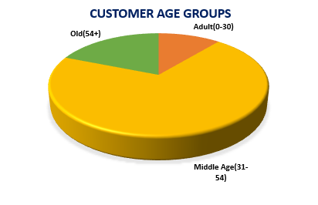
- Are there significant differences in bike purchases between male and female customers?
  - Males show slightly higher average income (≈58,000) compared to females (≈54,500).Bike purchase counts are fairly balanced across genders, but male lean slightly higher in ownership.
- Does marital status (single vs. married) affect bike purchase decisions?
  - Yes, marital status does affect bike purchase decisions.
- Single individuals show a higher likelihood of purchasing bikes, particularly in the middle-age group and with shorter commute distances.
- Married individuals are less likely to purchase bikes, possibly due to family responsibilities, higher car ownership, and longer commute requirements.
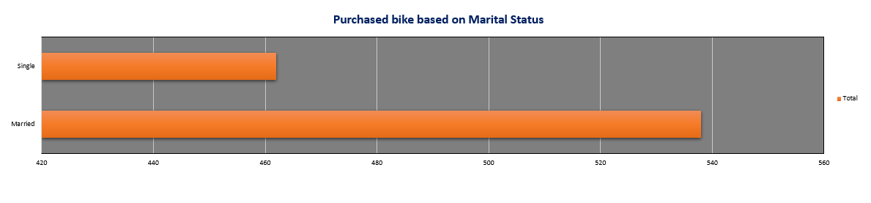
2. Socioeconomic Influences
- How does income level correlate with bike ownership or purchase?
  - Average income of bike purchasers is higher than non-purchasers (e.g., Male purchasers ≈60,124 vs. non-purchasers ≈56,208).
Indicates income positively correlates with bike purchase.
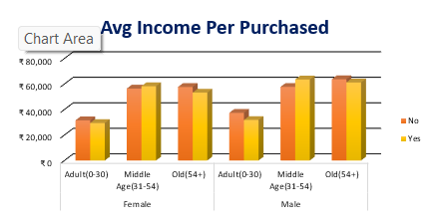

- What role does education level (High School, Bachelors, Graduate Degree, etc.) play in bike purchase behaviour?
  - Bachelors degree holders form the largest group of bike purchasers (306).
Graduate degree holders are fewer (174), while high school and partial college groups also contribute significantly. → Education level influences purchase, but mid-level education (Bachelors) dominates.
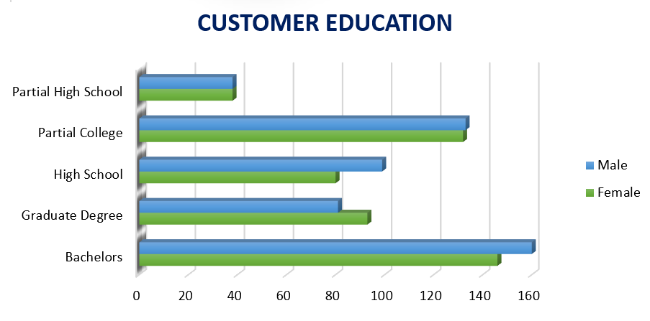

- Do certain occupations show higher tendencies to purchase bikes compared to others?
  - Yes, certain occupations show higher tendencies to purchase bikes. Professionals, Managers, and Clerical workers are more likely to purchase bikes. Manual and Skilled Manual workers are less likely to purchase bikes.
3. Lifestyle & Behavioural Factors
- How does commute distance (0–1 miles, 2–5 miles, 5–10 miles, more than 10 miles) affect bike purchase decisions?
  - Most bike purchases occur among people commuting 0–1 miles (366) and 5–10 miles (192).Very few purchases for “More than 10 miles” (111). → Suggests bikes are preferred for short to moderate commutes, not long distances.
  - 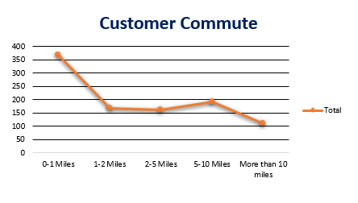
- Does home ownership status influence bike purchasing behaviour?
  - Yes, home ownership status does influence bike purchasing behaviour. Homeowners are more likely to purchase bikes, possibly because they have more financial stability and use bikes for short commutes. Non-homeowners are less likely to purchase bikes, which may be linked to lifestyle differences, longer commutes, or reliance on other transport modes.
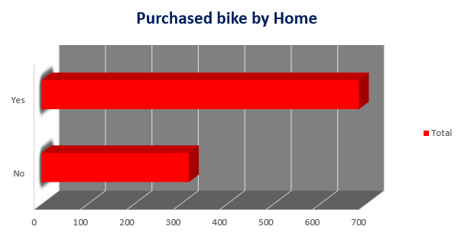
- How does the number of cars owned relate to the likelihood of buying a bike?
  - Individuals with fewer cars are more likely to purchase bikes. Owning multiple cars reduces likelihood of bike purchase.
4. Regional & Cultural Insights
- Are there regional differences (Europe, Pacific, North America) in bike purchase patterns?
  - North America shows the highest income contribution among bike purchasers (≈31.88M total income).
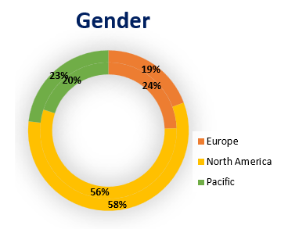
- Do cultural or regional commuting habits explain variations in bike ownership?
  - Yes, cultural and regional commuting habits do explain variations in bike ownership:
- Europe: Bikes are favoured for short commutes, reflecting dense urban living and strong cycling culture.
- North America: Higher-income individuals purchase bikes for medium commutes, showing suburban commuting influence.
- Pacific: More purchases for mid-range commutes (5–10 miles), suggesting regional reliance on bikes for moderate travel distances.
5. Strategic Implications
- Which combination of demographic and lifestyle factors most strongly predicts bike purchases?
  - From your pivot tables and raw data:
- Age Group: Middle-aged individuals (31–54) are the strongest buyers (701 out of 1000).
- Income: Higher income correlates with bike purchase (average income of purchasers > non-purchasers).
- Commute Distance: Short (0–1 miles) and moderate (5–10 miles) commutes show the highest bike purchase counts.
- Cars Owned: Fewer cars = higher likelihood of bike purchase.
- Occupation: Professionals, Managers, and Clerical workers show higher purchase rates compared to Manual/Skilled Manual.
- Home Ownership: Homeowners are more likely to purchase bikes than non-homeowners.
- How can businesses use these insights to segment customers and design targeted marketing campaigns?
    - Segment 1: Urban Professionals (High Income, Short Commute)
Target with premium bikes, eco-friendly branding, and convenience-focused campaigns.
    - Segment 2: Middle-Aged Families (Homeowners, 1–2 Cars)
Promote family-friendly bikes, health benefits, and cost savings compared to cars.
    - Segment 3: Students & Young Adults (Lower Income, Short Commute)
Offer affordable entry-level bikes, instalment plans, and lifestyle branding.
    - Segment 4: Pacific Region Mid-Range Commuters (5–10 miles)
Highlight durability, comfort, and commuting efficiency.
- What strategies could be developed to increase bike adoption among groups with lower purchase rates?
  - Manual/Skilled Manual Workers:
- Provide affordable, rugged bikes with financing options.
- Partner with employers to offer bikes as part of workplace wellness or commute programs.
Older Age Group (54+):
- Promote e-bikes for easier commuting and health benefits.
- Highlight low-impact exercise and mobility advantages.

Non-Homeowners & Long-Distance Commuters (>10 miles):
- Introduce shared bike schemes or subscription models.
- Market e-bikes and hybrid bikes as practical alternatives for longer commutes.

Key Insights
Bike purchases are most strongly predicted by middle age, higher income, short-to-moderate commute, fewer cars, professional/clerical occupations, and home ownership. Regions also show cultural differences: Europe favors short commutes, North America favors medium commutes, and Pacific favors mid-range commuting.

Dashboard Screenshot
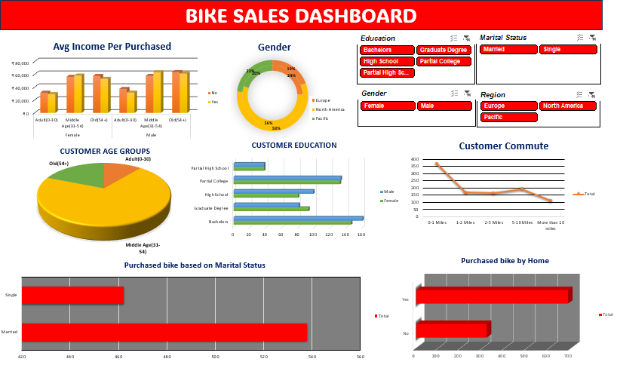

How to Explore
Open the Excel file, interact with filters, slicers, and charts.

-:END:-

